**DAILY ONLINE ACTIVITIES SUMMARY**

|  |  |  |  |  |  |  |  |  |
| --- | --- | --- | --- | --- | --- | --- | --- | --- |
| **Date:** | **10/06/2020** | | | | | **Name:** | **POOJA D S** | |
| **Sem & Sec** | **4th SEM 'B' Section** | | | | | **USN:** | **4AL18CS056** | |
| **Online Test Summary** | | | | | | | | |
| **Subject** | | **Object Oriented Concepts** | | | | | | |
| **Max. Marks** | | **30** | | **Score** | | | **22** | |
| **Certification Course Summary** | | | | | | | | |
| **Course** | **Introduction to Cyber Security** | | | | | | | |
| **Certificate Provider** | | | **Great Learning**  **Academy** | | **Duration** | | | **5.5 hour** |
| **Coding Challenges** | | | | | | | | |
| **Problem Statement:** A user will input two strings, and we find if one of the strings is a sub sequence of the other. Program prints “yes” if either the first string is a sub sequence of the second string or the second string is a sub sequence of the first string. Assume that, the length of the first string is smaller than or equal to the length of the second string. Assume that, the length of the first string is smaller than or equal to the length of the second string. | | | | | | | | |
| **Status: completed** | | | | | | | | |
| **Uploaded the report in Github** | | | | | **yes** | | | |
| **If yes Repository name** | | | | | <https://github.com/dspooja/Java-coding>  <https://github.com/dspooja/C-coding> | | | |
| **Uploaded the report in slack** | | | | | **yes** | | | |

Online Test Details: (Attach the snapshot and briefly write the report for the same)

Certification Course Details: (Attach the snapshot and briefly write the report for the same)

Coding Challenges Details: (Attach the snapshot and briefly write the report for the same)

ONLINE TEST DETAILS:

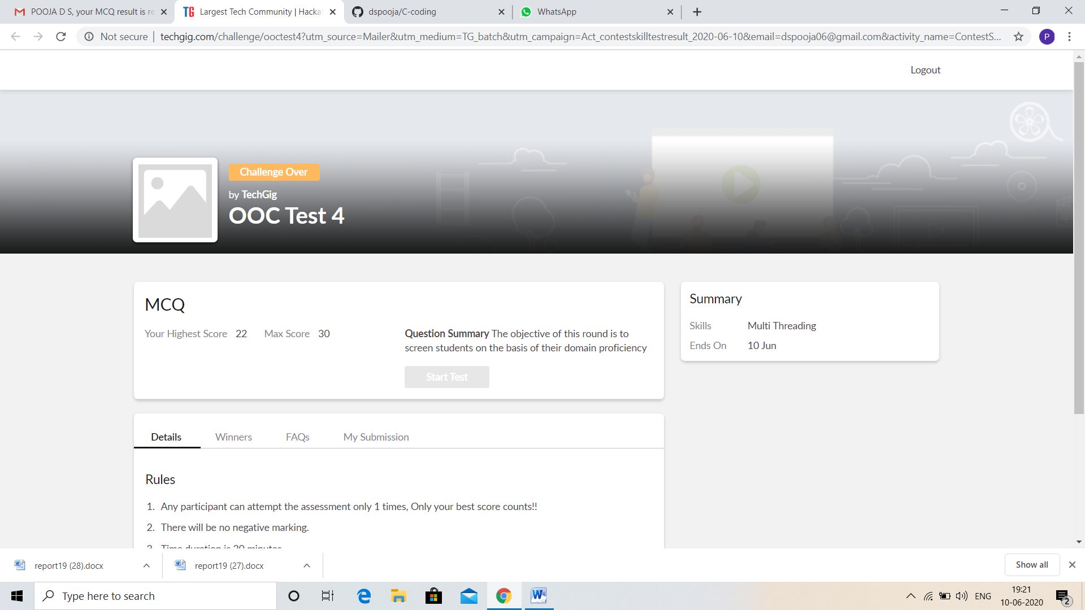

CERTIFICATION COURSE DETAILS:

* As continuation of the **Introduction to Cyber Security** online course**.**
* **The concepts covered in Introduction to Cyber Security are:**
* Threats and Vulnerabilities
* What is Cybersecurity

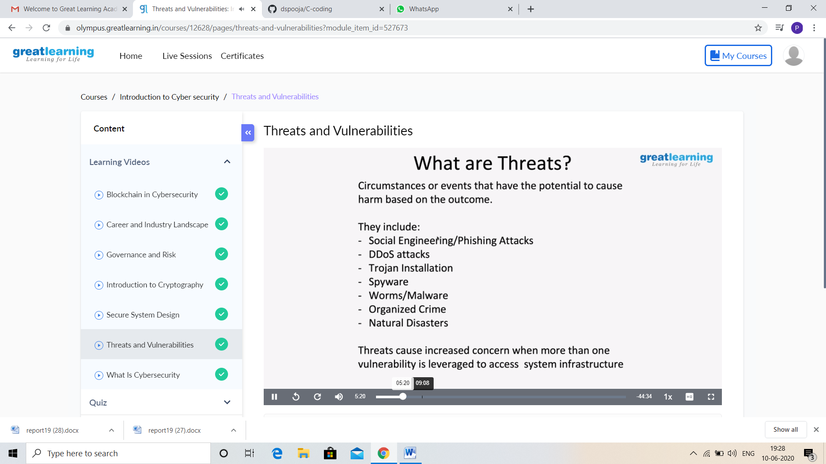

And I Participate in the Webinar “Brain Control Robot Design” on 6th June.

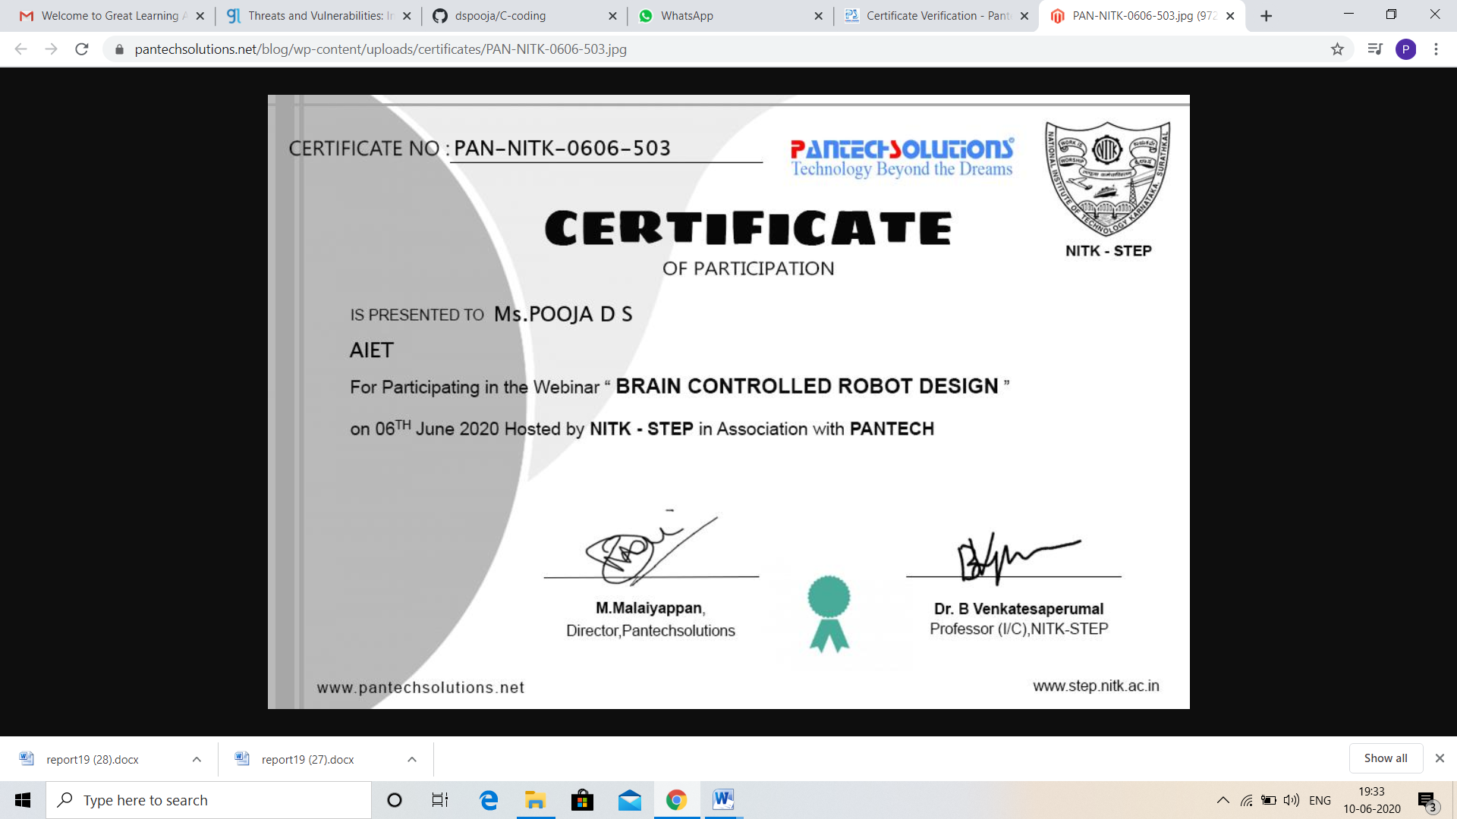

CODING CHALLENGES DETAILS:

Problem statement 1:

Write a C Program to print the sum of boundary elements of a matrix

Given a matrix, the task is to print the boundary elements of the matrix and display their sum.  
Sample Output 1:  
Enter M (Rows) and N (Columns): 3, 3  
Enter the Elements: 1 2 3 4 5 6 7 8 9  
OUTPUT:  
The Input Matrix is:  
1 2 3  
4 5 6  
7 8 9  
The Boundary Elements are: 1 2 3 4 6 7 8 9  
The Sum of Boundary elements of the Matrix is: 40

Sample Output 2:  
Enter M (Rows) and N (Columns): 4, 5  
Enter the Elements: 1 2 3 4 5 6 7 8 9 10 11 12 13 14 15 16 17 18 19 20  
OUTPUT:  
The Input Matrix is:  
1 2 3 4  
5 6 7 8  
9 10 11 12  
13 14 15 16  
17 18 19 20  
The Boundary Elements are: 1 2 3 4 5 8 9 12 13 16 17 18 19 20  
The Sum of Boundary elements of the Matrix is: 147

Solution: Uploaded it in github.

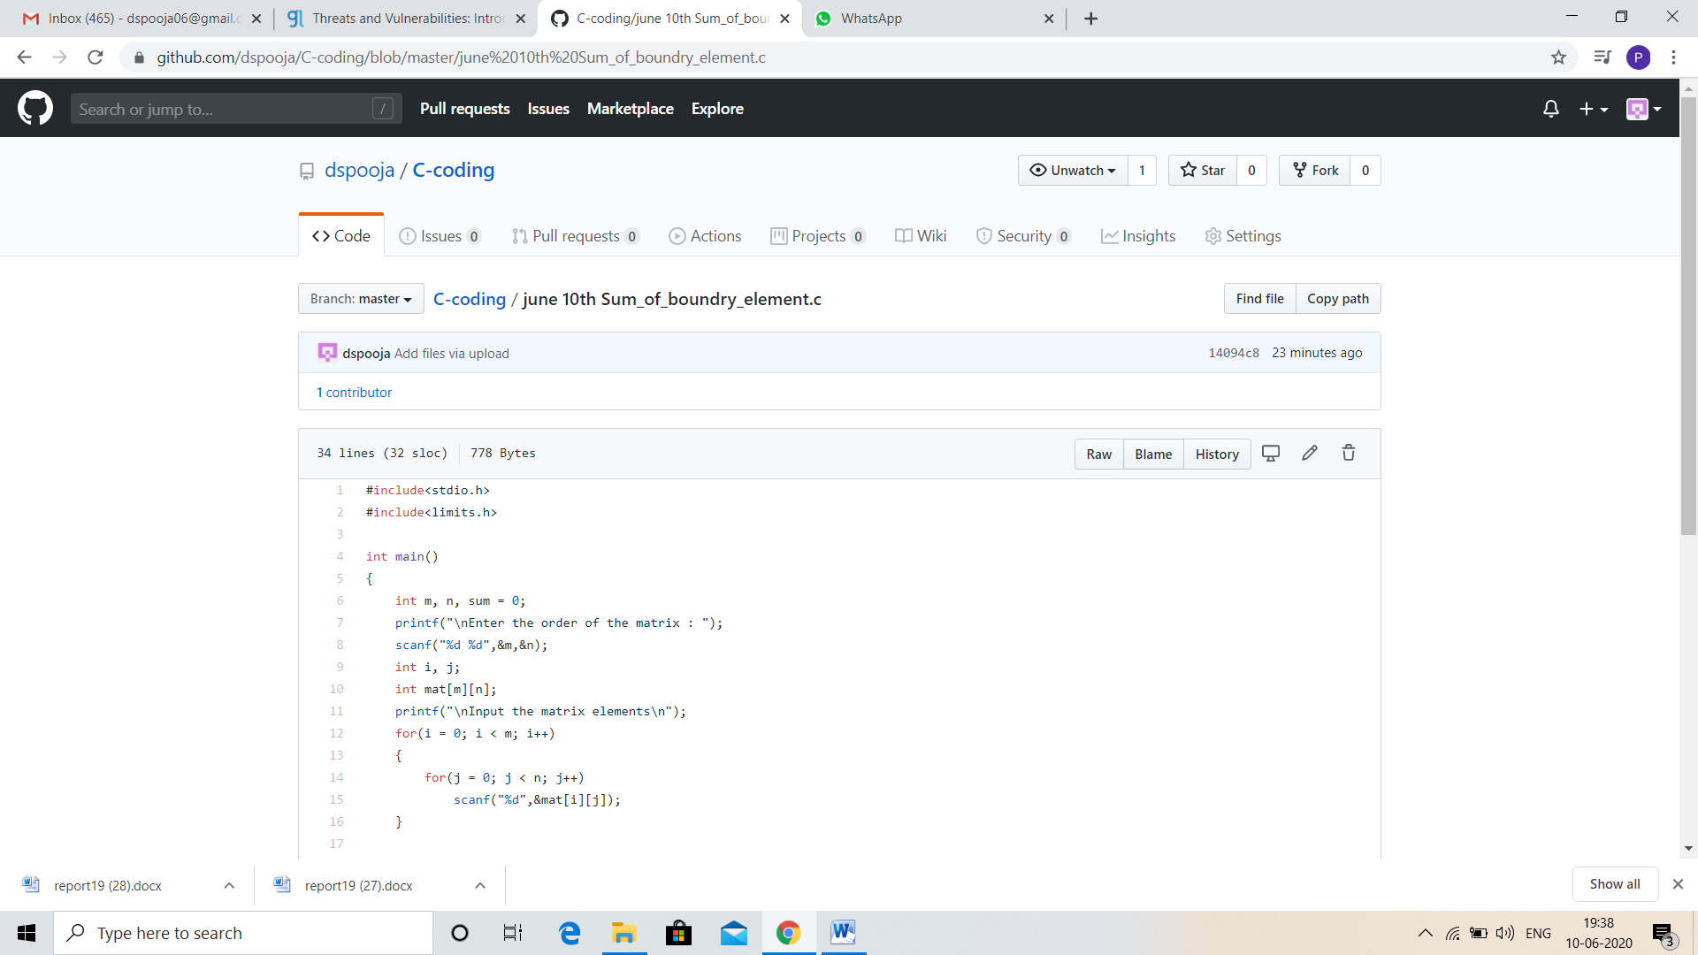

Problem statement 2:

Java Program to find the longest repeating sequence in a string  
string: acbdfghybdf

Solution: Uploaded in github.

